Professional Learning Community (PLC)
Sept. 16, 2014

What is a good PLC? What does it look like?

My Campus’ PLCs:
Rx

What is a Professional Learning Community?
Dufour, R. “What is a Professional Learning Community?” Educational Leadership May 2004: 6-11.
Introduction

Big Idea #1  Ensure Students Learn | Big Idea #2  Culture of Collaboration | Big Idea #3  Focus on Results
Conclusion-Hard Work and Commitment

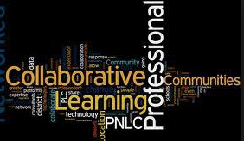

Productive
PLC

PLC and Planning
Back to Plus-Delta Prescription for Improvement

How will I ensure quality PLCs occur on my campus?

