[](https://youtu.be/P0zVPZBykSE?list=PLpzLAWxRHSdA4iTpa5N2kxDaeGd5-25p9)

Collaborative Instruction

Independent

Learning



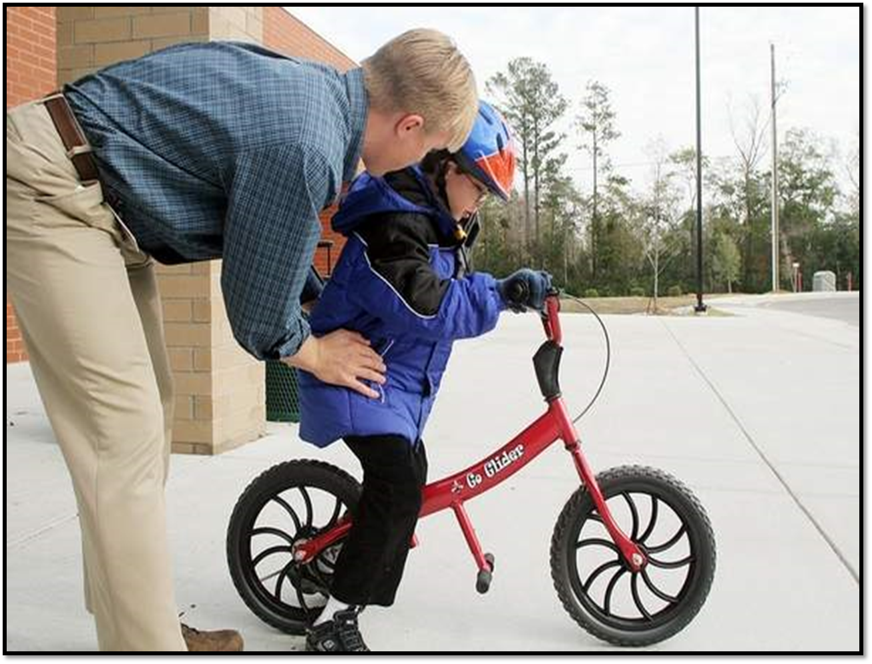

Focus Lesson



Guided Instruction