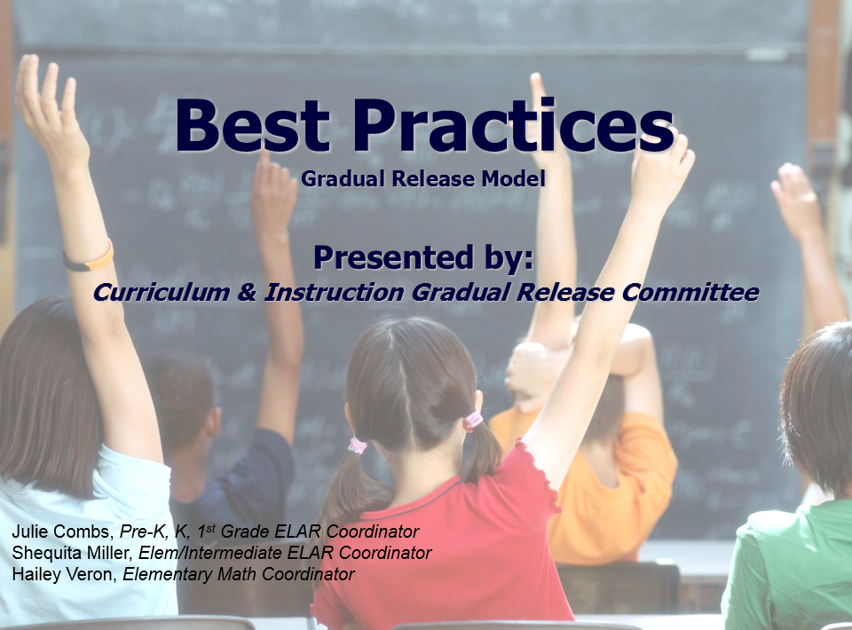

Curriculum and Instruction

Vision Statement

The vision of the C & I department is to ensure a common standard of excellence for all students in Crowley ISD.

Mission Statement

The mission of the C & I department is to develop consistency across the district through a guaranteed and viable curriculum, quality instruction, and continuous assessment through the sharing in the responsibility for all learning by providing support and guidance to ensure the success of all students.

How did you learn to ride a bike?

How would using the Gradual Release Model impact the way teachers plan and deliver their lessons?

What are the benefits of using the Gradual Release Model?
One Word Summary…

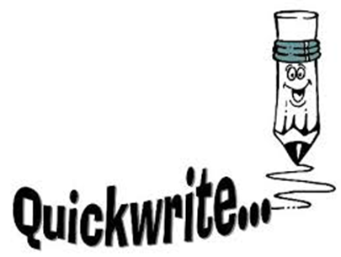
I Used to Think…, Now I Think

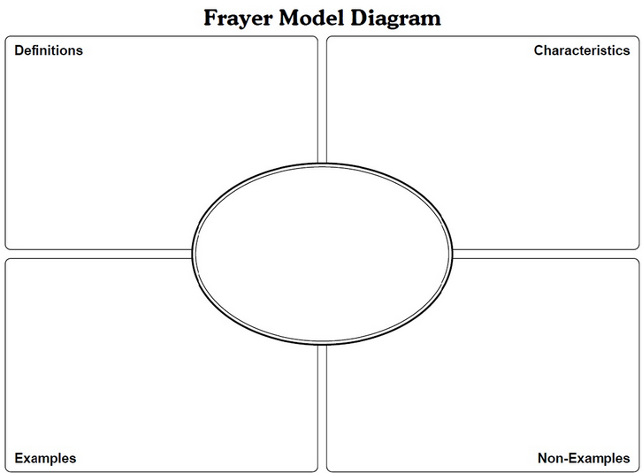
Learning Purpose & Focused Instruction
I Do”

Zaption Video Notes:
Look for how the teacher:
- sets the purpose and objective,
- what metacognition she models,
- and use of “I” statements

Discuss how the teacher used modeling, demonstrating, and direct explanation to introduce a skill and execute key instructional moves designed to make what is being taught transparent to the learner.
Guided Practice
I Do”

Zaption Video Notes:
Look for how the teacher uses collaborative learning vs. group work (cooperative)

Discuss the difference between basic group work and productive group work?
Independent Learning
I Do”
Zaption Video Notes:
Look for how the teacher:
- Assess at the close of the lesson to determine mastery
- Goes back to the objective to reinforce the goal of the lesson

How does the independent work reinforce concepts that have been previously taught?
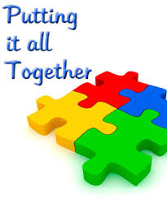
Video Notes:
I Do It | We do it together | You do it (I watch and guide) | You do it alone
Focus Lesson Modeled Instruction | Shared/Guided Instruction | Guided Practice – Collaborative | Independent

